Strong naming an assembly.

We have two types of assembly in .Net Environment.

1. Strong Named Assembly
2. Weak Named Assembly

For simple C# program to print message to console we are using Console class. Console class is present in system namespace, and system namespace is present on the system assembly. The system assembly is a .Net framework assembly.

When we install .Net, two very important components get installed. One is .Net frame work class library and other is run time environment (CLR). .Net frame-work class library has multiple assembly and all these assembly get installed to GAC (Global assembly cache). The path for GAC is (C:\Windows\assembly).

An Assembly consist of 4 parts.

1. Simple textual name.
2. Version Information.
3. Culture information (other wise the assembly is language neutral).
4. Public key token.

We as assembly is signed with public key token. It is called as strongly named assembly.

When globalizing application, we use cultural information. When we specific culture that becomes satellite assembly.

[Assembly.AssemblyCulture(“”)]

Public key token : I Need to sign my assembly with public private key pair. We need key file that has these key and it can be generated by using strong name key tool to generate the key file. Generate it as shown in screenshot.

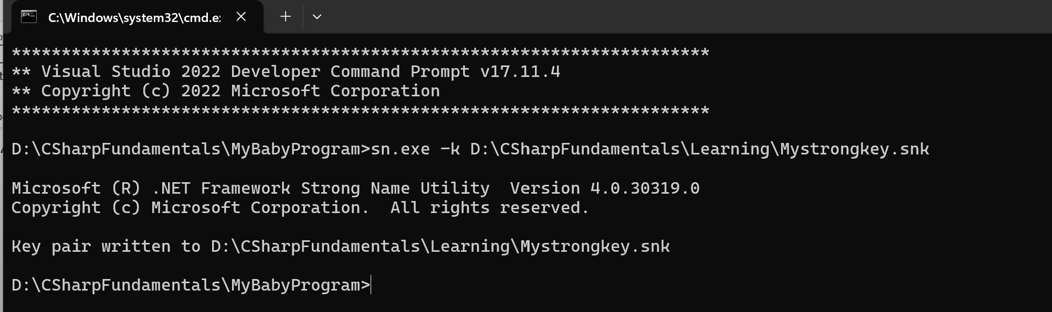

Use below command in assembly file to sign it with strong key.

[assembly:AssemblyKeyFile(“D:\CSharpFundamentals\Learning\Mystrongkey.snk”)]

Only strong named assemblies can be deployed to GAC. Deploying weak named assembly in GAC will result in DLL Hell.

